Tribhuvan University

Faculty of Humanities and Social Sciences
Nepa_watches
(Payment integration in Ecommerce)
A PROJECT REPORT

Submitted to
Department of Computer Application
Asian College of Higher Studies
In partial fulfilment of the requirements for the Bachelor in Computer Application

Submitted by
Bishal Rauniyar [210615]

2024/03/10
Under the supervision of
Mahesh Man Maharjan

Tribhuvan University
Faculty of Humanities and Social Sciences
Asian College of Higher Studies (ACHS)

Supervisor’s Recommendation

I hereby recommend that this project prepared under my supervision by Bishal Rauniyar entitled “Payment integration in Ecommerce” in partial fulfilment of the requirements for the degree of Bachelor of Computer Application be recommended for the mid-evaluation.

SIGNATURE
Mahesh Man Maharjan

---------------------------
SUPERVISOR
Asian College of Higher Studies (ACHS)
Ekantakuna, Jawalakhel

Tribhuvan University
Faculty of Humanities and Social Sciences
Asian College of Higher Studies (ACHS)
LETTER OF APPROVAL
This is to certify that this project prepared by Bishal Rauniyar and entitled “Nepa_watches” in partial fulfilment of the requirements for the degree of Bachelor in Computer Application (BCA) has been evaluated. In our opinion, it is good and satisfactory in the scope and quality of a project for the required degree.
SIGNATURE OF SUPERVISOR

Mahesh Man Maharjan
SIGNATURE of Internal Examiner
SIGNATURE of Coordinator

Pranaya Nakarmi

Acknowledgement

This project would not have been possible without the help and guidance of many individuals despite the huge efforts from our side.
We would like to extend our sincere thanks to all. We are indebted to the Asian College of Higher Studies (ACHS) and its members for their support and supervision and for providing the necessary information regarding this project. Also, we would like to thank our project guide Mahesh Man Maharjan for his kind co-operation and guidance which has helped us in the completion of the project.
We give our special thanks and kind appreciation to our seniors, colleagues, and a few individuals for their help during our project.

Abstract

The Payment Integration in Ecommerce system is like having a reliable assistant for handling all your online transactions smoothly. It's designed to make sure that when customers want to buy something from your online store, the payment process is easy and secure. Think of it as the cashier at a physical store, but for your online shop. Its main job is to make sure that when customers want to pay for their purchases, everything goes smoothly and quickly, just like swiping a credit card at a store. By using Payment Integration in Ecommerce, you're making life easier for both your customers and yourself. Customers will feel more confident buying from your store because they know their payment details are safe. And for you, it means less hassle dealing with payment processing and more time to focus on other aspects of your business. This system is like having a trusty assistant who's always there to help out with the money stuff, so you can concentrate on providing the best products and service to your customers.

Keywords: Payment Integration, Ecommerce, Online transactions, Secure platform, Smooth payment processing, Customer confidence, Hassle-free checkout, Improved business focus.

Table of Contents
Acknowledgement iii
Abstract iv
Table of Contents v
List of Figures vi
Chapter 1: Introduction 1
1.1 Background of the study 1
1.2 Aim 1
1.3 Objectives 2
1.4 Research Questions 2
1.5 Rational of study 3
1.6 Organizational of the study 3
2.1 Technical Review 4
2.1.1 4
2.2 Thematic Review 5
Chapter 3: Research Methodology 6
3.1 Research Design 6
3.2 Population and Sampling 7
3.3 Sampling Techniques: 9
3.4 Site Selection 9
3.5 Ethical Consideration 10
Chapter 4: Data Analysis and Presentation 12
Chapter 5: System Design and Testing 15
5.1 DFD Diagram 15
Level 0 DFD 15
Level 1 DFD 16
Level 2 DFD 17
5.2 E-R Diagram 18
5.3 Activity Diagram 19
5.4 Process Model: Prototyping 21
5.5 Testing 23
Chapter 6: Summary and Conclusion 24
References 25
Appendices 26

List of Figures
Figure 1:DFD Level 0 15
Figure 2 DFD Level 1 16
Figure 3DFD Level 2 17
Figure 4 E-R Diagram of Nepa_watches 18
Figure 5 User Side Activity Diagram 19
Figure 6 Admin Side Activity Diagram 20

Chapter 1: Introduction

1.1 Background of the study
Payment Integration in Ecommerce is a vital component of online retail platforms, facilitating seamless and secure transactions for both merchants and customers. Developed to streamline the payment process, it eliminates the need for manual handling of transactions by enabling automatic payment processing. Just as the Attendance Management System simplifies attendance tracking in educational institutions, Payment Integration in Ecommerce revolutionizes the way businesses handle online payments. Instead of manual record-keeping, merchants can rely on this system to electronically process payments, reducing errors and enhancing efficiency. Similar to how the Attendance Management System verifies student identification, Payment Integration in Ecommerce ensures secure transactions by authenticating customer payment details. Whether through biometric verification or card-based authentication, the system safeguards sensitive financial information, instilling confidence in customers and merchants alike. Furthermore, like the Attendance Management System's ability to generate reports and monitor student success, Payment Integration in Ecommerce provides valuable data insights. Merchants can analyze transaction trends, identify purchasing patterns, and optimize their business strategies to drive growth and maximize revenue. In essence, just as the Attendance Management System is indispensable for educational institutions to monitor attendance and improve student outcomes, Payment Integration in Ecommerce is essential for businesses to streamline payment processing and enhance customer satisfaction in the digital marketplace.

1.2 Aim
The aim of Payment Integration in Ecommerce is to make online shopping smoother by offering various payment options, ensuring security, and supporting global transactions. It's about helping businesses grow by providing insights into customer behavior and optimizing their operations. Ultimately, the goal is to create a hassle-free and secure payment experience that keeps customers coming back for more.

1.3 Objectives
The objectives of this study include:
- To Simplify checkout: Integrate payment methods seamlessly, reducing steps for customers, and enhancing transaction ease.
- To Ensure security: Implement robust encryption, fraud detection, and comply with PCI DSS standards, fostering trust and guarding against breaches.
- To Enhance user experience: Optimize interface, offer clear instructions, and minimize loading times for a smooth payment process, boosting satisfaction.
- To Provide insights: Generate transaction reports, analyze purchasing patterns, and identify areas for improvement to drive business growth effectively.

1.4 Research Questions
- What are the most preferred payment methods among online shoppers, and how does offering multiple payment options impact conversion rates and customer satisfaction?

- How do security measures in payment integration influence consumer trust and mitigate risks associated with online transactions?

- What are the key factors contributing to cart abandonment rates during the checkout process, and how can businesses optimize their payment flow to reduce abandonment?

- How do cultural and regulatory differences across regions affect the adoption of payment methods and the success of ecommerce ventures in international markets?

- What are the emerging trends and technologies in payment integration, and how can businesses strategically leverage them to enhance their competitiveness and customer experience?

1.5 Rational of study
The study on Payment Integration in Ecommerce is motivated by the crucial role that smooth payment processes play in the success of online retail ventures. With the digital marketplace continuously evolving, it's imperative for businesses to grasp consumer preferences, address security concerns, and adapt to emerging payment trends effectively. By delving into the efficacy of different payment methods, security protocols, and strategies to combat cart abandonment, the research aims to offer valuable insights for optimizing payment procedures, enhancing customer satisfaction, and ultimately driving revenue growth. Moreover, examining the impact of cultural nuances and regulatory frameworks on payment adoption, as well as exploring the potential of emerging technologies, contributes to a holistic understanding of payment integration challenges and opportunities. Through this study, businesses can gain actionable insights to inform their decision-making processes and bolster their competitive edge in the ecommerce landscape. [1]

1.6 Organizational of the study
- Getting Started: This section introduces you to the world of payment integration in ecommerce. We'll talk about why it's important and what you can expect to learn from this chapter.
- Understanding Payment Methods: Here, we'll explore the different payment options available to online shoppers. From credit cards to digital wallets, we'll break down how each method works and what factors influence their popularity.
- Ensuring Security: In this part, we'll discuss the importance of security in online transactions. We'll explore the measures businesses take to protect your payment information and how you can identify a secure payment process.
- Navigating Checkout: This section is all about the checkout process. We'll look at common challenges shoppers face during checkout and share tips for making the process smoother and more user-friendly.
- Exploring Emerging Trends: Finally, we'll wrap up by discussing the latest trends and technologies shaping the future of payment integration in ecommerce. From biometric authentication to cryptocurrency, we'll explore what's on the horizon and how it might impact your online shopping experience. [2]

Chapter 2: Literature Review

2.1 Technical Review
2.1.1 Introduction:
In the realm of e-commerce mobile apps, literature delves into their crucial role, benefits, and obstacles. This study illuminates their pivotal function in enhancing interactions between businesses and consumers in the digital market.
2.1.2 Importance of User Engagement:
User engagement in e-commerce apps is vital, fostering brand loyalty and revenue growth. E-commerce apps serve as potent tools for nurturing user engagement.
2.1.3 Enhancing Communication and Networking:
Effective communication and networking within e-commerce organizations are crucial for growth. Utilizing technology like Slack and engaging customers through social media strengthens relationships and drives business growth.
2.1.4 Challenges in Implementation:
Implementing e-commerce mobile apps faces challenges like technological complexity and security concerns. Success requires careful planning, agile methodologies, and continuous optimization.
2.1.5 User Management System Success Factors:
User-friendliness, reliability, and customization are crucial for system effectiveness. These factors ensure successful implementation.
2.1.6 Conclusion:
E-commerce mobile apps are strategic tools for businesses in the digital market. Prioritizing user engagement, communication, and user experience fosters growth and innovation, providing competitive advantage in e-commerce.

2.2 Thematic Review
- Market Analysis:
Conduct comprehensive research to understand the watch market's size, trends, and competitive landscape, helping identify opportunities for growth and differentiation.

- Consumer Behavior:
Study consumer preferences, demographics, and purchasing habits related to watches to tailor the e-commerce site's offerings and marketing strategies effectively.

- Competitor Analysis:
Analyze competing watch e-commerce sites to identify strengths, weaknesses, and opportunities for differentiation, guiding the development of a unique value proposition.

- Technology Infrastructure:
Assess the technology requirements for the e-commerce site, including platforms, payment gateways, and security measures, to ensure a seamless and secure shopping experience for customers.

- Marketing and Promotion:
Develop a robust marketing strategy leveraging digital channels like SEO, social media, and email marketing to increase brand visibility, attract customers, and drive sales for the watch e-commerce site.

Chapter 3: Research Methodology

  - Research Design
The research design for studying Payment Integration in Ecommerce will be structured around a mixed-methods approach, incorporating both qualitative and quantitative methods to gain a comprehensive understanding of the topic. This approach allows for the exploration of various dimensions of payment integration, including consumer behavior, technological advancements, security concerns, and regulatory compliance. [3]
- Quantitative Research Component:

- Surveys: Conducting surveys among online shoppers to gather data on payment preferences, satisfaction levels with current payment methods, and perceptions of security.
- Transaction Data Analysis: Analyzing transaction data from ecommerce platforms to identify patterns in payment methods usage, transaction volumes, and conversion rates.
- Statistical Analysis: Utilizing statistical techniques such as regression analysis to identify correlations between payment methods, consumer demographics, and purchase behavior.

- Qualitative Research Component:

- Interviews: Conducting in-depth interviews with ecommerce merchants, payment service providers, and industry experts to gain insights into the challenges and opportunities in payment integration.
- Focus Groups: Organizing focus group discussions with online shoppers to explore their experiences, concerns, and preferences regarding payment methods and security measures. [4]
- Case Studies: Examining case studies of successful and innovative payment integration strategies implemented by ecommerce businesses to understand best practices and lessons learned.

- Mixed-Methods Integration:

- Triangulation: Integrating findings from both quantitative and qualitative data sources to validate and complement each other, providing a more comprehensive understanding of payment integration dynamics.
- Sequential Design: Using a sequential design approach where quantitative data collection and analysis precede qualitative data collection, allowing for deeper exploration and contextualization of quantitative findings. [5]
- Convergent Design: Employing a convergent design approach where quantitative and qualitative data are collected concurrently and analyzed separately before integrating findings to provide a holistic perspective on payment integration.
- Overall, this mixed-methods research design will enable a nuanced exploration of Payment Integration in Ecommerce, yielding insights that can inform strategic decision-making for businesses and contribute to the advancement of knowledge in the field.

3.2 Population and Sampling
- Population:
The population for this study consists of two main groups:
- Online Shoppers: Individuals who regularly engage in online shopping across various ecommerce platforms.
- Ecommerce Businesses: Companies or individuals that operate online retail stores and utilize payment integration systems.
- Sampling:
To ensure representativeness and reliability of findings, the following sampling methods will be employed for each group:
- Online Shoppers:

- Random Sampling: Selecting a random sample of online shoppers from different demographic backgrounds (age, gender, income level, geographic location) to ensure diversity.
- Stratified Sampling: Dividing the population of online shoppers into distinct strata based on demographic characteristics and then randomly selecting samples from each stratum to ensure proportional representation. [6]
- Convenience Sampling: Sampling individuals who are easily accessible and willing to participate in the study, such as through online surveys or social media platforms.

- Ecommerce Businesses:
-Purposeful Sampling: Selecting ecommerce businesses that represent a diverse range of industries, sizes (small, medium, large), and levels of payment integration sophistication.
-Snowball Sampling: Identifying initial participants through industry contacts or professional networks and then asking them to refer other ecommerce businesses that may be suitable for the study.
-Expert Sampling: Selecting individuals with specialized knowledge or experience in ecommerce and payment integration, such as industry consultants or technology providers, to provide valuable insights.
- Sample Size:
The sample size for each group will be determined based on the research objectives, desired level of confidence, and statistical power. Efforts will be made to ensure an adequate sample size that allows for meaningful analysis and generalizability of findings within the constraints of available resources.

3.3 Sampling Techniques:
- Online Surveys: Employing online survey platforms to reach a large and diverse sample of online shoppers, utilizing random or stratified sampling methods.
- Interviews and Focus Groups: Conducting semi-structured interviews and focus group discussions with selected participants to gather in-depth qualitative insights, using purposeful or snowball sampling techniques.
- Transaction Data Analysis: Analyzing transaction data from ecommerce platforms, utilizing systematic sampling techniques to extract representative samples for analysis based on predefined criteria. [7]
By employing a combination of sampling methods tailored to the characteristics of each population group, this study aims to gather comprehensive and insightful data on Payment Integration in Ecommerce.

3.4 Site Selection
For the purpose of this study on Payment Integration in Ecommerce, site selection will involve identifying and choosing appropriate online platforms and businesses to gather data from. The selection process will focus on ensuring diversity, relevance, and accessibility of the chosen sites.
- Diversity:
Sites will be selected to represent a diverse range of ecommerce platforms, including popular online marketplaces, niche specialty stores, and independent retailers. This diversity will ensure that the study captures a broad spectrum of payment integration practices and consumer experiences across different types of online businesses.
- Relevance:
Sites selected for data collection will be relevant to the research objectives and questions of the study. This includes targeting platforms and businesses that actively utilize payment integration systems and technologies, as well as those that cater to a significant volume of online transactions.
- Accessibility:
Accessibility considerations will be taken into account when selecting sites to ensure ease of data collection and analysis. Preference will be given to platforms and businesses that provide readily available data sources, such as transaction records, customer reviews, and payment processing documentation. Additionally, efforts will be made to secure permissions and cooperation from site owners or administrators to facilitate data collection activities.
- Sampling Criteria:
The sampling criteria used for site selection will align with the overall sampling strategy of the study. This may include criteria such as site popularity, transaction volume, geographic location, industry sector, and technological sophistication of payment integration systems.

- Data Collection Methods:
Various data collection methods, such as web scraping, survey administration, interviews with site administrators or business owners, and analysis of publicly available information, will be employed to gather relevant data from selected sites.
By carefully considering diversity, relevance, accessibility, and sampling criteria in the site selection process, this study aims to ensure comprehensive coverage and robust data collection from a range of online platforms and businesses relevant to Payment Integration in Ecommerce. [7]
  - Ethical Consideration
- Respecting Participants:
- Treat participants with respect, dignity, and fairness throughout the research process.
- Ensure that participants fully understand the purpose, procedures, and potential risks of the study before agreeing to participate.
- Protecting Privacy:
- Safeguard the confidentiality and anonymity of participants' personal information.
- Store data securely and avoid disclosing personally identifiable information without explicit consent.
- Ensuring Informed Consent:
- Obtain informed consent from participants before their involvement in the study.
- Clearly explain the purpose of the research, potential risks, and their rights as participants.
- Minimizing Harm:
- Take steps to minimize physical or psychological harm to participants.
- Provide resources and support for participants who may experience distress during the research process.
- Maintaining Integrity:
- Conduct research with honesty, integrity, and transparency.
- Avoid conflicts of interest and disclose any potential biases or influences that could affect the research outcomes.

Chapter 4: Data Analysis and Presentation
This report analyzes data on payment integration in e-commerce websites, aiming to understand user behavior, identify trends, and recommend strategies for optimizing the checkout process.
Data Collection and Preparation
- Data Sources:
  - Website analytics data (e.g., Google Analytics)
  - Payment gateway reports
  - Customer surveys on checkout experience
  - Abandoned cart data
- Data Preparation:
  - Clean and organize data into a usable format (e.g., spreadsheet)
  - Identify and address missing values or inconsistencies
  - Calculate relevant metrics (e.g., conversion rate, abandoned cart rate, average order value)
Data Analysis
1. Payment Method Preferences:
- Analyze the percentage of transactions completed using different payment methods (credit card, debit card, digital wallets, etc.)
- Identify any variations in preference by demographics (age, location) or product categories.
- Use visualizations like bar charts or pie charts to show the breakdown.
2. Abandoned Cart Analysis:
- Investigate the rate of abandoned carts at different stages of the checkout process (e.g., shopping cart, payment selection, address entry).
- Identify potential reasons for abandonment through surveys or heatmaps.
- Analyze if specific payment methods contribute more to abandonment.
3. Conversion Rate by Payment Method:
- Calculate the conversion rate (percentage of visitors completing a purchase) for each payment method.
- Identify any significant differences in conversion rates.
- Use this data to determine which payment methods are most effective at driving sales.
4. Security and Fraud:
- Analyze the incidence of fraud attempts for different payment methods.
- Investigate the effectiveness of fraud prevention measures employed by the payment gateway.
- Consider including a chart showing the distribution of fraudulent transactions across payment methods.
5. Mobile Payment Integration:
- Analyze the percentage of transactions completed on mobile devices.
- Investigate the user experience of mobile checkout with different payment methods.
- Recommend improvements to optimize the mobile checkout process for various payment options. [2]
Presentation and Recommendations
- Visualizations: Utilize charts, graphs, and tables to present findings clearly and concisely.
- Insights and Recommendations:
  - Highlight key takeaways from the data analysis on customer payment preferences, checkout behavior, and security considerations.
  - Recommend strategies for optimizing payment integration based on the findings:
    - Expanding payment options based on user preference.
    - Streamlining the checkout process, especially for mobile users.
    - Implementing effective fraud prevention measures for different payment methods.
    - Analyzing the cost-benefit of offering various payment options.
Additional Considerations:
- Include limitations of the data analysis (e.g., data sample size).
- Suggest further research or A/B testing to validate assumptions or explore new strategies.
- Tailor the report's language and recommendations to your target audience (e.g., business executives, technical team).
By providing insightful data analysis and concrete recommendations, this report can help e-commerce businesses optimize their payment integration strategies to improve customer experience, increase conversion rates, and ensure secure transactions.

Chapter 5: System Design and Testing
  - DFD Diagram

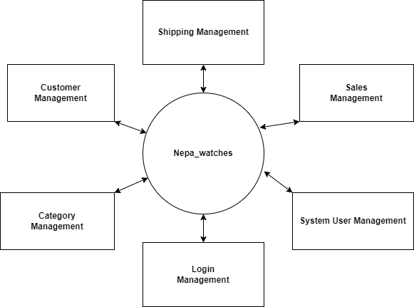
Level 0 DFD
Figure 1:DFD Level 0

Level 1 DFD
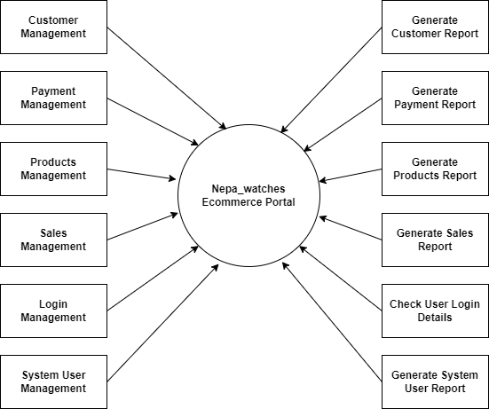
Figure 2 DFD Level 1

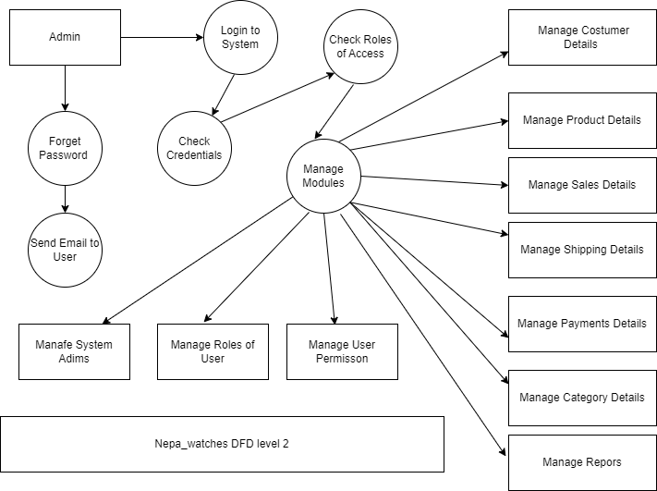
Level 2 DFD
Figure 3DFD Level 2

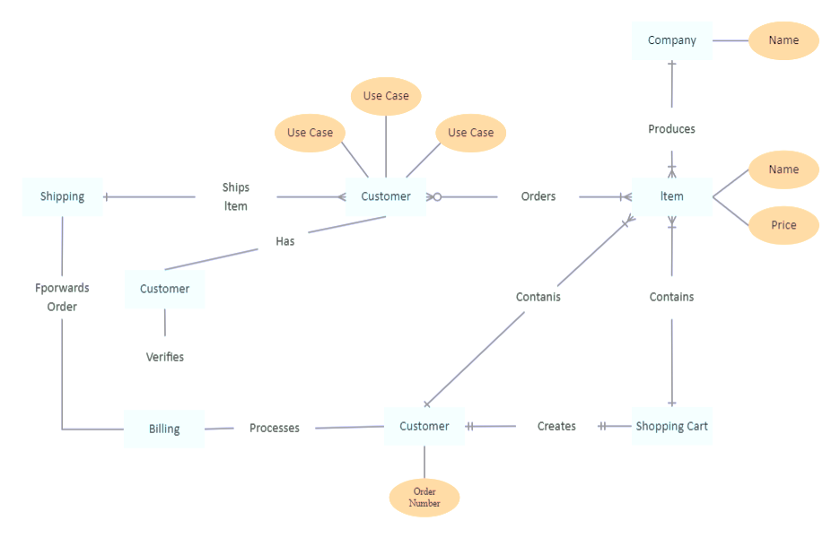
5.2 E-R Diagram
Figure 4 E-R Diagram of Nepa_watches

  - Activity Diagram
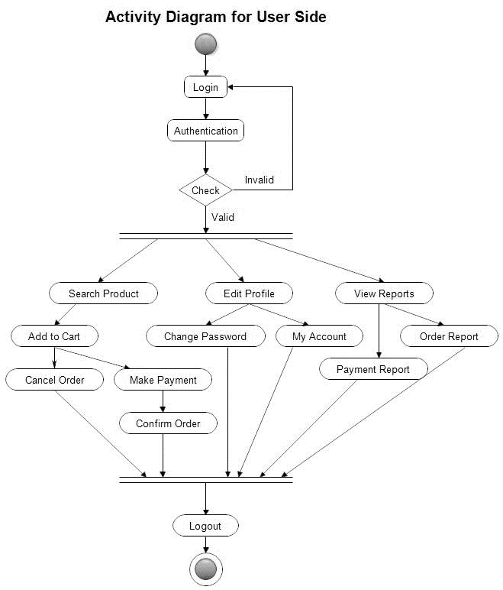
Figure 5 User Side Activity Diagram

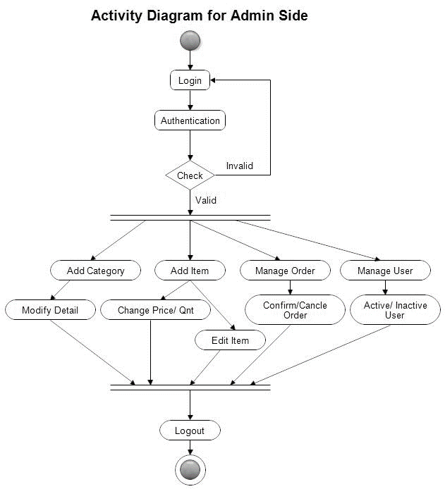
Figure 6 Admin Side Activity Diagram

5.4 Process Model: Prototyping

The proposed methodology for developing the Nepa Watches e-commerce website is the Prototyping Model. This model is chosen due to the need for iterative development and continuous refinement of the website's features and functionalities to ensure alignment with user preferences and market trends.

The following phases are selected for the completion of the project:

i. Initial Prototype Development:

Collect initial requirements from stakeholders.
Develop a basic prototype of the website to showcase key features and functionalities.
ii. Prototype Refinement:

Gather feedback from stakeholders and users on the initial prototype.
Iterate on the prototype based on feedback to enhance usability, functionality, and design.
iii. Detailed System and Software Design:

Develop a comprehensive design based on the refined prototype, incorporating detailed specifications for system architecture, database structure, and user interface elements.
iv. Prototype Implementation and Testing:

Programmers implement the prototype according to the detailed design specifications.
Conduct unit testing to identify and address any issues or bugs in the implementation.
v. Prototype Evaluation and User Feedback:

Release the prototype to a select group of users for evaluation and feedback.
Gather user feedback to further refine and improve the prototype.
vi. Iterative Prototyping:

Iterate on the prototype based on user feedback, making continuous improvements to the website's features, design, and functionality.
vii. Finalization and Deployment:

Finalize the prototype based on user feedback and stakeholder input.
Prepare the website for deployment, ensuring it meets quality standards and is ready for public release.
Prototyping Model of Nepa Watches E-commerce:

In the Prototyping Model for Nepa Watches, the iterative process begins with the development of an initial prototype, followed by continuous refinement based on user feedback and stakeholder input. This approach allows for flexibility and agility in responding to changing requirements and market dynamics, ultimately resulting in a website that meets the needs and preferences of its users effectively.
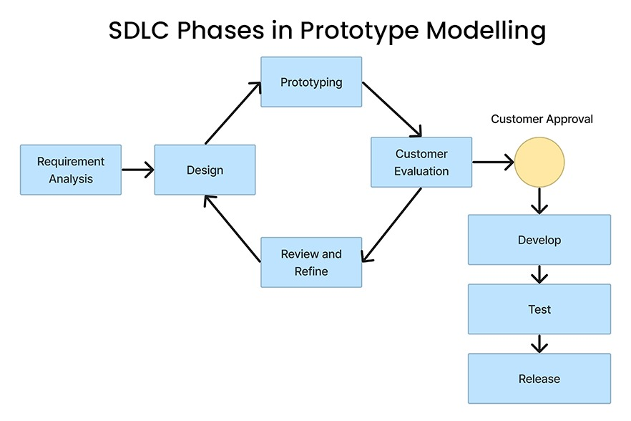
Figure 7 Process Model

5.5 Testing
Testing is a crucial process that evaluates the functionality of a software application, aiming to discover errors and ensure its completeness and quality. It goes beyond mere debugging and involves various testing strategies to achieve a defect-free and high-quality product.
Black Box Testing: This technique focuses on evaluating the software's functionality without considering its internal structure. Valid and invalid inputs are provided to check for the expected output responses, including system and functional testing. Here, we selected a set of valid and invalid input and code execution conditions and checked for valid output responses. It includes system testing and functional testing.

White Box Testing: This methodology validates the internal components and mechanisms of the application. Code is executed with predefined inputs to verify the expected outputs, including unit testing of individual app pages and integration testing of different modules. Here, we took preselected input values for the validation of preselected output values.

Unit Testing: During initial development, each unit of the system is tested for anomalies and errors, covering syntactical and logical aspects. In this project, unit testing is done by testing individual components (such as Login, Signup, Forgot Password, Inserting), ensuring layout, CSS, and database connections are functioning correctly.

Chapter 6: Summary and Conclusion
In this final chapter, we summarize the key findings and conclusions drawn from our study on Nepa Watches, exploring its market positioning, product offerings, marketing strategies, and future prospects.
- Market Positioning and Product Offerings
Nepa Watches has positioned itself as a premium watch brand catering to individuals seeking both style and functionality. Through our analysis, we identified the unique selling propositions of Nepa Watches, including its craftsmanship, use of high-quality materials, and commitment to sustainability. The company's product offerings range from classic timepieces to innovative smartwatches, appealing to a diverse customer base.
- Marketing Strategies
Nepa Watches employs a multi-faceted marketing strategy to reach its target audience and drive brand awareness. This includes a strong online presence through social media platforms, influencer partnerships, and engaging content marketing initiatives. Additionally, Nepa Watches utilizes traditional marketing channels such as print advertisements and retail partnerships to expand its reach globally.
- Customer Engagement and Satisfaction
Customer satisfaction is at the core of Nepa Watches' business philosophy. Through exceptional customer service, personalized shopping experiences, and a focus on community engagement, Nepa Watches has built a loyal customer base. By listening to customer feedback and continuously improving its products and services, the company fosters long-term relationships with its clientele. [5]
- Future Prospects
Looking ahead, Nepa Watches is well-positioned for continued growth and success in the competitive watch industry. With a strong brand identity, innovative product development, and a customer-centric approach, the company is poised to capitalize on emerging market trends and technological advancements. By staying true to its core values while embracing change, Nepa Watches can navigate future challenges and seize new opportunities for expansion.
- Conclusion
In conclusion, our study of Nepa Watches highlights the brand's journey to becoming a reputable player in the watch market. Through a combination of quality craftsmanship, strategic marketing efforts, and a dedication to customer satisfaction, Nepa Watches has carved out a niche for itself in an industry dominated by established players

References

[1] | A. K. P. R. A. Amol Gawande, "Challenges, opportunities, and best practices for an alumni association," 2023.
[2] | J. Chase, "Relationship Building: The Key to Alumni Engagement," 17 05 2021. [Online]. Available: https://er.educause.edu/articles/2021/5/relationship-building-the-key-to-alumni-engagement.
[3] | H. R. M. S. V. M. S. S. Eileen Mona, "Alumni Social Networking Site," International Journal of Scientific Research in Computer Science Engineering and Information Technology, 2021.
[4] | K. &. M. F. &. Z. S. Jacksi, "Ecommerce Management System," Ecommerce Management System, vol. 6, no. 10.21276/sjet.2018.6.2.1, pp. 49-53, 2018.
[5] | A.-S. G. A.-S. M. M. R. I. M. Khalifa A. Haza, "Factors affecting university image among graduate alumni: A case study of Qatar university," Heliyon 8(6), 2022.
[6] | S. S. K. N. Preethy Sinu Kurian, "Alumni mentoring: An approach to build community of learners," SHS Web of Conferences , 2023.
[7] | H. B. B. V. T. Sasikumar R, "Alumni Info-Com Management with Distinct Classification of Data," International Research Journal of Multidisciplinary Technovation , 2020.
[8] | projectmanager, 2022. [Online]. Available: https://www.projectmanager.com/guides/waterfall-methodology.
[9] | S. a. Z. M. Hassan, "Web-based Ecommerce Management System," 2015.

Appendices


Home Page (Landing Page/Login Page)
Products

Product Selection & Details
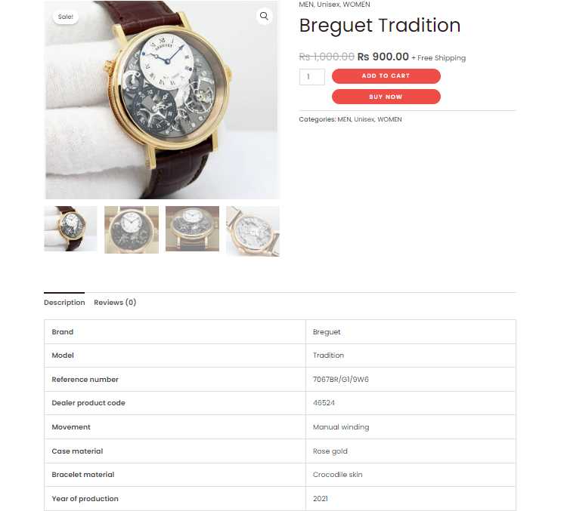

Cart
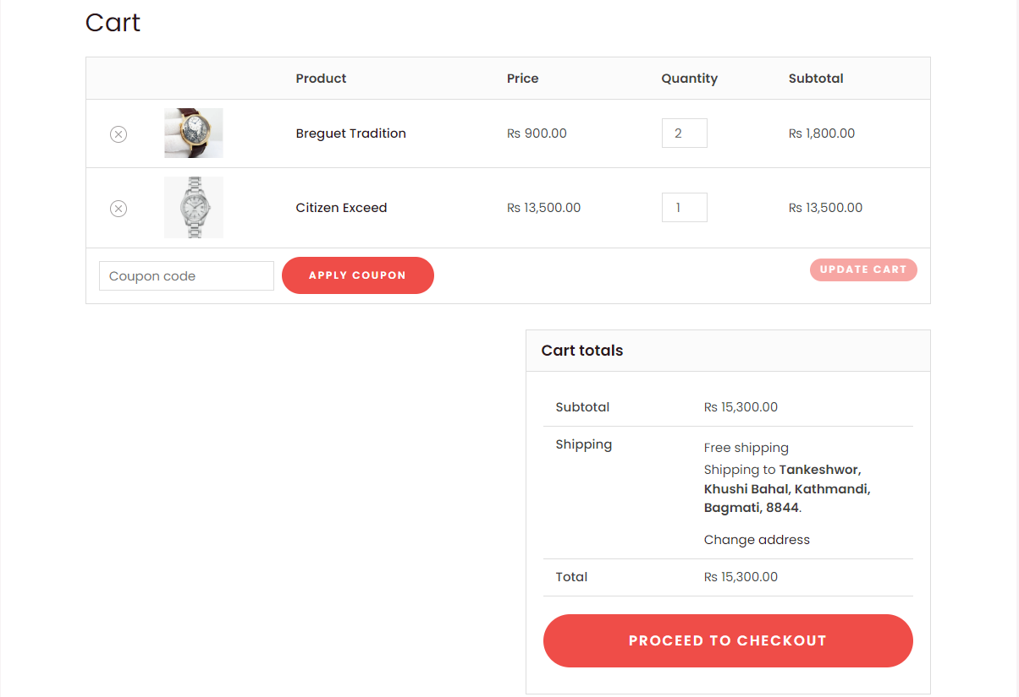
Checkout and Payment with Esewa
